**Low-fidelity mockup**

* **Challenge type: progression**
* **Duration: Entire day**
* **Deadline**: end of the day
* **Team challenge** : Groups

# Objective

Before starting the realization of the final design of a website, a designer goes through several intermediate stages. Let’s discover the low-fidelity mock-up today:

The idea is to refine the wireframe by focusing on the arrangement of the elements, the spaces between them as well as the font.

# Definition

A low-fidelity mock-up is a more detailed version of the wireframe. It may include basic colors, typography, and images to give a rough idea of the design, but it is still quite basic and focuses on functionality rather than aesthetics. Low-fidelity mock-ups help designers to further refine their ideas and get feedback from clients or team members before moving on to more detailed designs.

Look at this image, it looks like the wireframe, but boosted:

[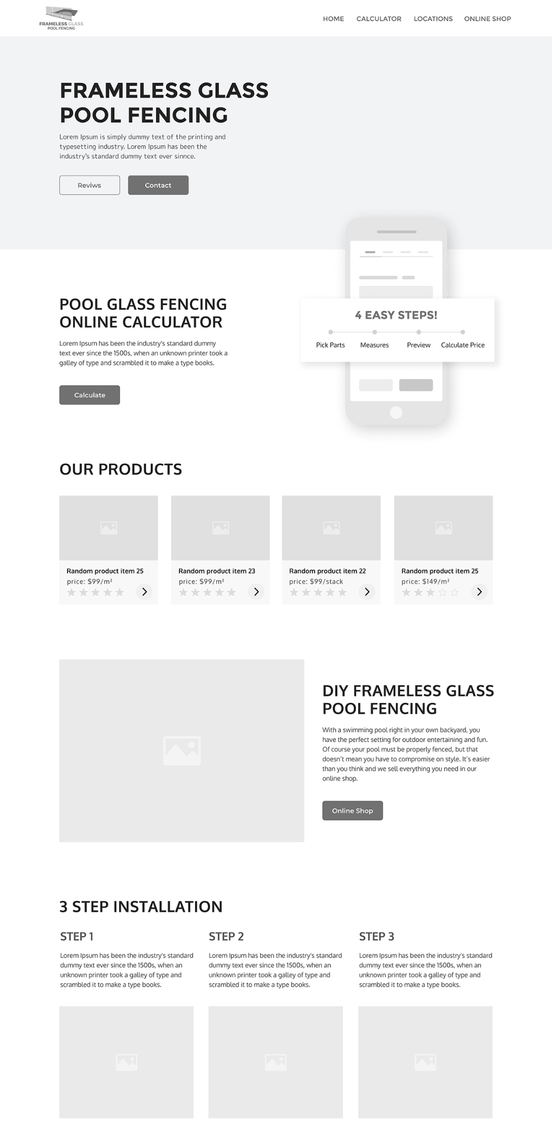](https://drive.google.com/file/d/1K3v_H4D9uyGJOtXGE_Pk0I_x-4U062aV/view?usp=share_link)

[You can find this file here](https://drive.google.com/file/d/1Mo8SCte35A9Io4BSwa8kT171QDilAS4t/view?usp=share_link)

Here we start to pay attention to the dimensions, to the arrangement of the elements, to the font, to the size of the font… On the other hand, we do not take care of the details, such as the colors, the images, the precise shape of the buttons, the logo...

# Exercise

The goal is to adapt the wireframe that we started yesterday.

1. Take your wireframe back to Figma.
2. From there put in place the important blocks. Think about dimensions and spaces.
3. Fo

At the end of the day we will discuss your results with the team

# Pedagogical objectives

* Explore the conception of the design of a website.
* Use Figma.
* Work as a team on the same tool.